Professional Design (Do-it-for-me) Website Plans

Overview

Contents
Messaging 2
Quick Pitch 2
Top-line Benefits 2
Supporting Statistics...…….....…………………………………...………………………...……...………..2
Detailed Benefits 2
Features 4
Features Overview 4
Customer Experience 6
Sales Support 11
Probing Questions 11
Selling Points 11
Objection Handlers 12
Frequently Asked Questions 14
General. 14

Messaging

Quick Pitch
Drive more customers through the doors of small businesses with a professional online presence.
Get the competitive edge with a professional website that builds trust with customers, gets users found online, and allows them to reach out to their customers on social media, with email marketing, and more.
Unlike other website design options, our plans are affordable, and include domain-based email and monthly maintenance, so business owners can call in to make updates whenever they need to keep their website fresh and credible with their customers.
With plans including up to 10 pages of professional design it’s easy to find a plan that meets the needs of a small business.

Top-line Benefits
- Work with experts: Our team of experts is waiting to help business owners get a website that works for their business, so they can focus on their day-to-day.
- Build a strong online presence: 98% of consumers search online for products or services before they buy. Are they finding the business or their competition?
- Be mobile ready: The website will reformat to the size of different devices, so visitors will be impressed on desktop, tablet and smartphone screens.
- Ongoing updates: Monthly maintenance time with our Website Consultants means users can call in to make edits and updates to keep the website up-to-date and stay credible, with no extra work or investment.
- Domain and email included: Business owner’s domain and email should be promoting the brand front and center. Our design plans come with domain-based email, where users can easily create email accounts and access them from anywhere through Webmail.

Competitive Information
See Competitive Analysis

Supporting Statistics
First Impressions matter: 94% of people say web design is the reason they mistrust a website (DatAchieve Digital, 2022)
Poor design can impact online sales: 70% of online shoppers abandon their carts because of poor UX. (Truelist, 2023)
Investing in Design helps to put businesses above their competitors: 67% of users prefer to read beautifully designed content. (Zyro, 2022)

Detailed Benefits

Modern, Engaging Design Themes | - Fresh, responsive design themes.  - Automatically optimizes the website across devices, including desktops, tablets, and smartphones.
1-on-1 Consultation | - A consultant will walk the user through recommendations and discuss what makes the most sense for their business.  - Send in images and content to be included on the website.
Launch in 30 days | - From purchase to online, the website will be up in 30 days.
Online Store options | - Have a designer create an Online Store for the business, and set up products, tax, shipping and more.
Easy Management | - View website progress and submit images and feedback through the Project Center.  - Access an intuitive online dashboard to manage the online presence, domain and other services.  - View website analytics, including traffic, clicks and most popular pages.
24/7 Access | - Anytime, anywhere access. Manage the website from anywhere that has an Internet connection.

Features

Features Overview
Personalized Consultations | - Within 2 business days, a Website Coordinator will call the customer to book their 1-on-1 consultation to discuss their business needs and plan the website.  - The website Coordinator will manage the design of the website with a designer, copywriter, and quality assurance team.  - Discuss the business needs and preferences with the consultant and fill out a creative brief online.
Project Center | - Users can view the website progress and submit images and feedback through the Project Center, an intuitive online dashboard to manage their online presence, domain and other services.  - Submit any images or content to be included on the website through the Project Center or email the Website Coordinator directly.  - Throughout the process, users will get emails prompting them to log in to the Project Center and review drafts of their website.  - 24/7 access to manage the website from anywhere that has an Internet connection.
Design and Copy | - The website will be designed from an engaging, modern design theme, and will be optimized to look perfect on all devices: desktop, tablet and smartphones.  - Our web team will build up to 10 professionally designed pages, including a Home Page, About Page, and Contact Us Page.  - Our dedicated team of web copy writers will create quality content.  - Users can submit their own images or have their designer choose from professional, modern royalty-free photography.  - Basic on-site SEO updates for each page of the site, includes updates to Title Tags, Alt Tags, H1, H2, Meta Description and Sitemap.
Engaging Website Elements | - Add a Call-to-Action button to encourage site visitors to take action such as emailing, calling, accepting special offers and more.  - Add a contact form to easily allow visitors to send their name, email address and a message to a user’s email.  - Publish business hours of operation so web visitors and customers know when the business is open.  - Add a YouTube video to boost online presence.  - Add a File Area to allow visitors to download brochures, price guides, product sheets or other files.
Ongoing Monthly Maintenance | - The Professional Design package includes ongoing monthly maintenance time with a Website Consultant.  - Stay on top of updates to the existing website including text and images, contact details, and updates to existing modules and features, just by submitting a request or making a phone call.
Hosting, Domain and Email Included | - The Professional Design plan includes reliable, secure web hosting.  - Get branded, domain-based email for the business. Create and manage accounts and get access to emails anywhere through Webmail. It can sync with mobile devices and integrates calendars and contacts across the organization for simplified collaboration with employees.  - One domain name will be registered at the time of purchase.
Access to Online Presence Builder | - Users can choose to make edits to their website themselves through our easy-to-use editor, Online Presence Builder.  - Accessible 24/7 through the management dashboard, Online Presence Builder makes it simple to make updates on the fly.
Marketing and Management Tools Included | - Users can access all the tools they need to successfully build and market their business online through the management dashboard.  - Create and manage email, SEO, social and more.
Website Analytics | - View the website analytics to gain insight into traffic and visitor behavior.

Customer Experience
Customers will receive their Welcome email with log-in access to the Project Center. The Project Center is an intuitive online dashboard where customers can manage their professional design services, submit content and images, and review drafts of the website or other design services.
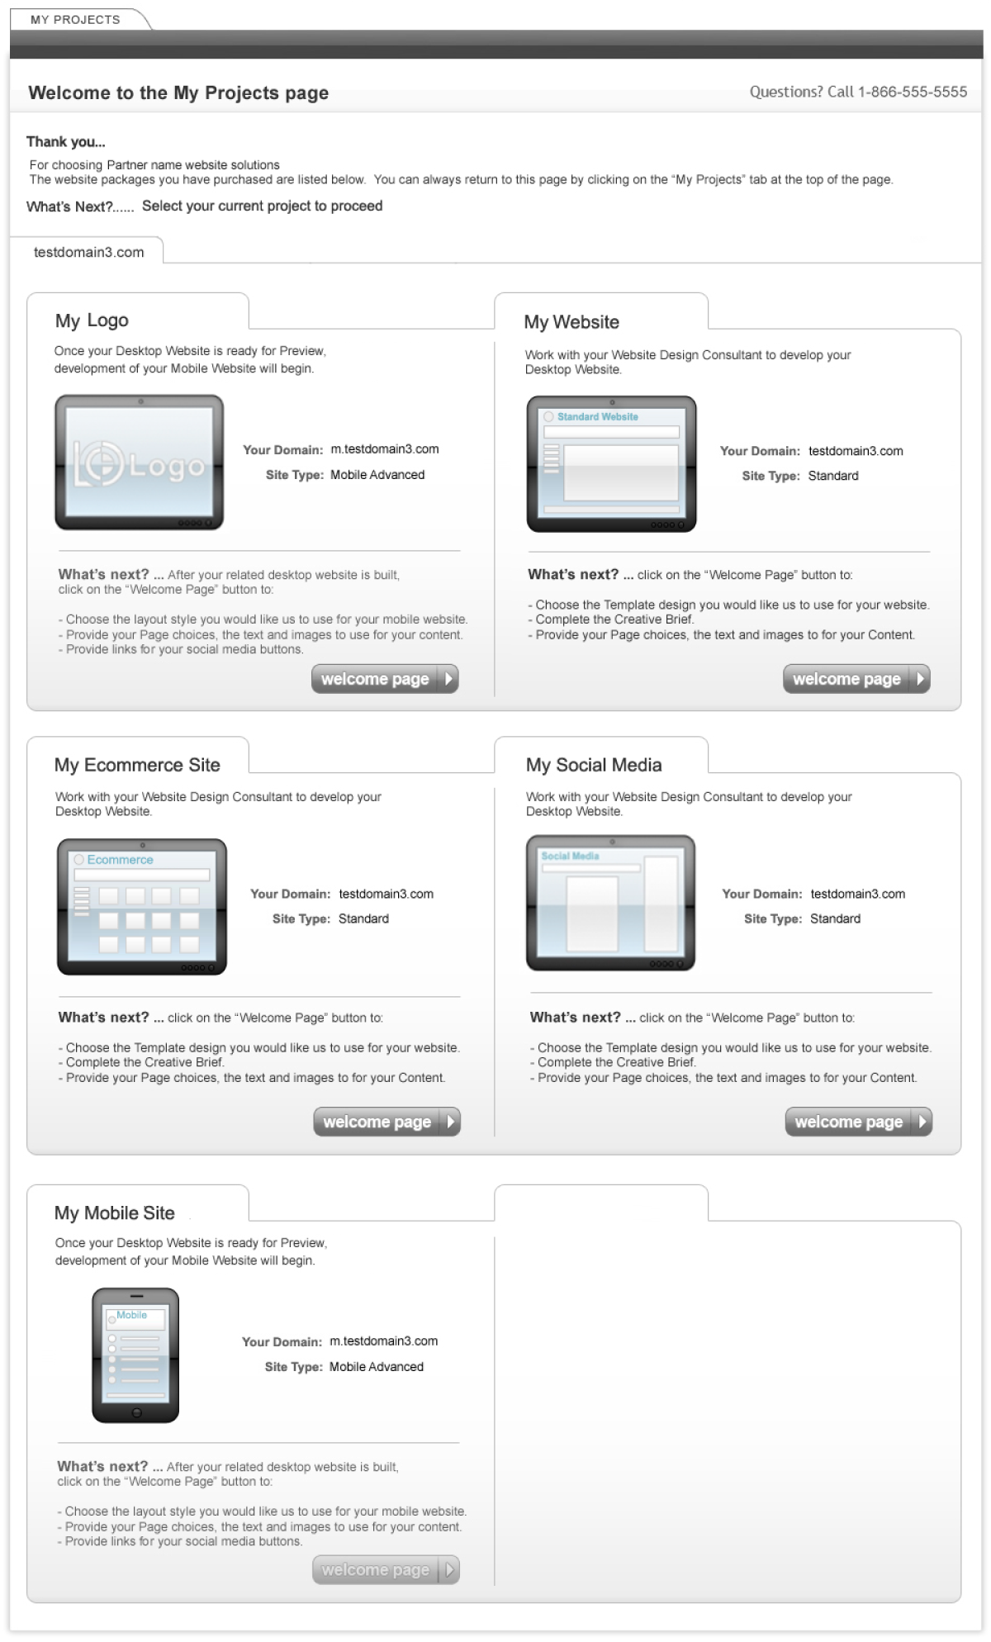

Within 2 business days, a Website Consultant will call the customer to book their 1-on-1 consultation to discuss their business needs and plan their website. The consultant will manage the design of the website with a designer, copywriter and quality assurance team.

Users can submit any images or content to be included on their website through their Project Center. They can also fill out a creative brief to share their design preferences and required content.
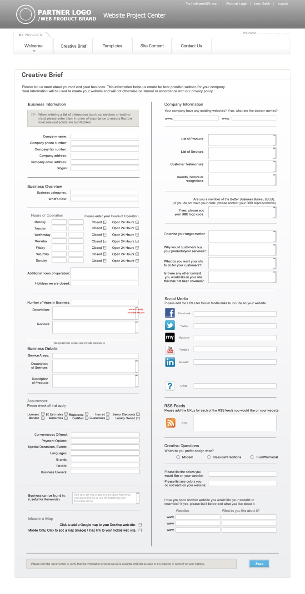

Users can choose a design theme for the designer to base the website layout on.
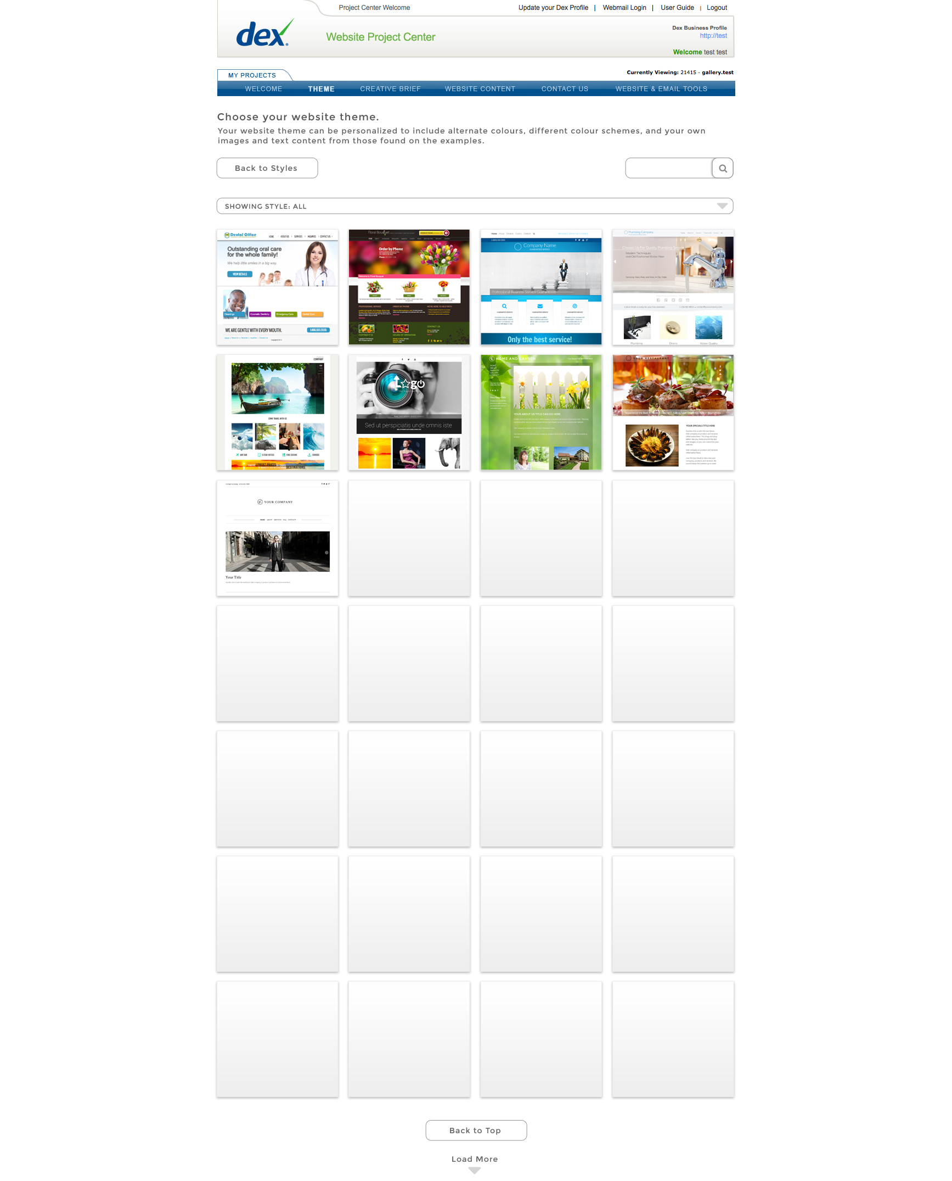
If desired, they can submit content to be included on the website.
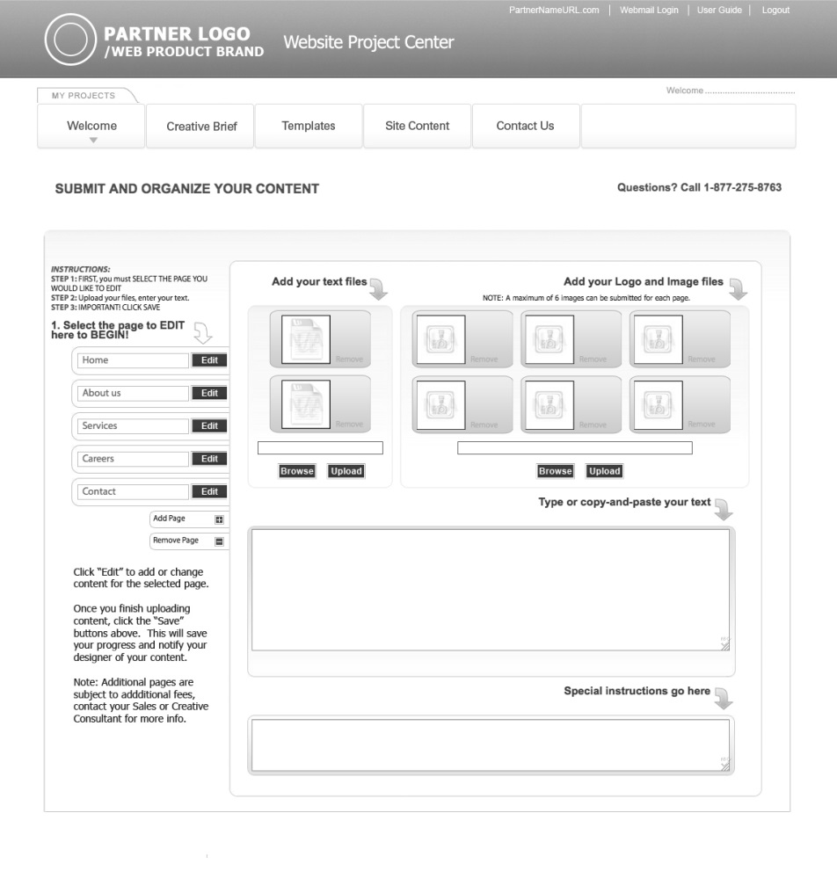
Users can also use the Project Center to contact their Website Consultant.
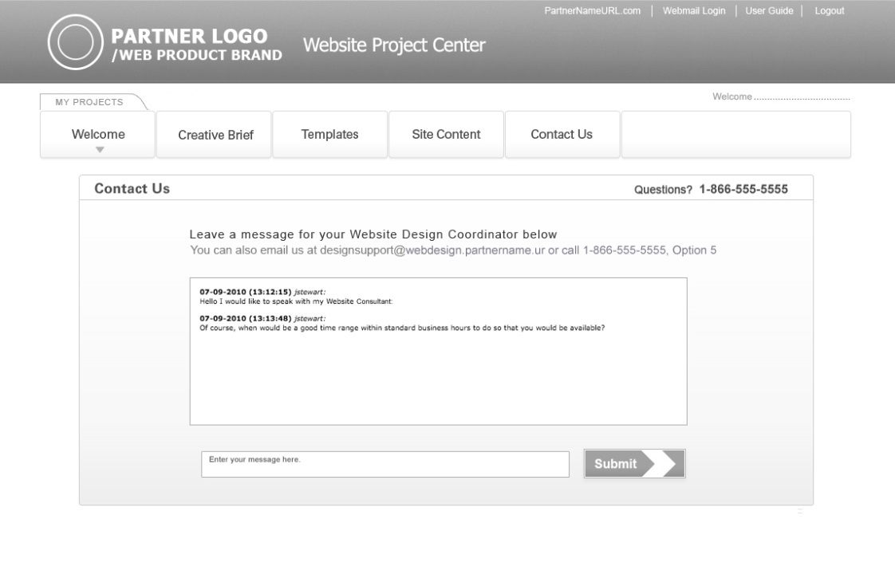
The standard delivery is 30 days. Throughout the process, the customer will get emails prompting them to log in to the Project Center and review drafts of their website. After a final review, the website will be launched!

Customers also have ongoing monthly maintenance time included to make updates to the website. When it’s time to make an update, they can submit a request through the Project Center, or call into the design team.
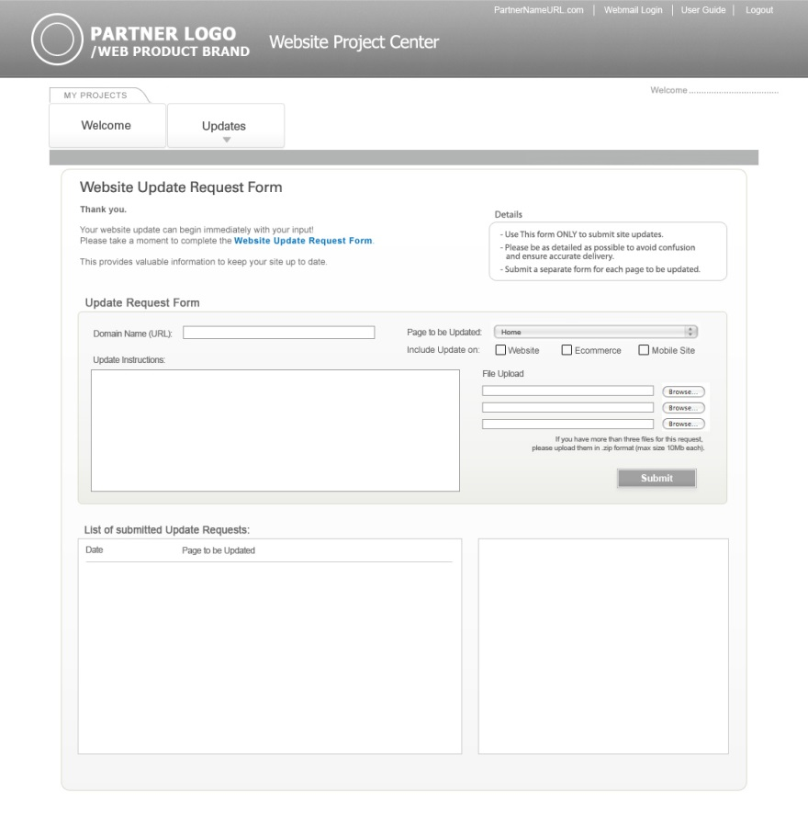

Sales Support

Probing Questions
What would happen if I Googled what your business offers, in your city? Would your business show up?
Do you know that 9 out of 10 purchases start online? You need to get found online, and have your professional website come up when customers are searching.
We have an option where one of our designers will build a professional website that gets your business found online. Plus, a domain, branded email, and features that drive your visitors to action.
I can have a Website Consultant call you to get started tomorrow. What do you think?

Do you have a website?
- Yes?
  - How could your website be improved: design, mobile-friendly, selling online, attract new customers?
- No?
  - Great, don’t lose any more time waiting! It’s important to have a professional online presence, so customers can trust your business’ credibility.
  - I have a solution that won’t take up your time or cost you an arm and a leg. We offer Professional Design website packages, where you work with a consultant and design team to build your business a website that will work for you.

Is your website optimized for mobile? Are you aware that Google will only show mobile-friendly websites to users searching on their smartphones?
72% of consumers who search on a computer/tablet go to a store within 5 miles of their location. (SMA Marketing, 2022)
88% of consumers visit a store within a day after conducting a local search on their smartphone. (Finances Online, 2023)
Your professionally designed website will perform perfectly across devices.

Selling Points
Get a website that is right for your business: Every business is different, and you need a website that works for you. A restaurant needs a menu page, while a concert venue needs an events calendar.
Work with experts: Our team of experts is waiting to help you get a website that works for your business, so you can focus on your day-to-day.
Ongoing updates: Monthly maintenance time with our Website Consultants means you can call in to make edits and updates to keep your website up-to-date and stay credible, with no extra work or investment.
Domain and email included: Your domain and email should be promoting your brand front and center. Our design plans come with domain-based email, where you can easily create email accounts and access them from anywhere through Webmail.

Why should I choose Professional Design?
- We have built thousands of websites for businesses just like yours. Our team of experts will design a site that works for you and helps customers connect with your business online.
- A professional website means more lead generation, more phone calls, more walk-ins, and a way to market your business online.
- Our plans are affordable, and include monthly maintenance, so you can call in to make updates whenever you need to keep your website fresh and credible with your customers.
- Our plans also include business-class email, web hosting, and other marketing tools to help grow your business online.

Objection Handlers
I already have a website / happy with my current provider.
Is your design modern? Is your website up to date? Is it mobile-friendly?

First impressions are extremely important. It takes no more than a split second (50 to 500 milliseconds) for users to form an opinion about your website (CXL, 2022).
First impressions are 94% design-related. (DatAchieve Digital, 2022)
94% of people cite design as a reason they do not trust certain websites. (DatAchieve Digital, 2022)
Your new website will be modern, professionally designed, and will be built responsive, so it looks great on every device.

If someone else makes changes for you, do they charge and are they able to make changes quickly?
Can you easily make changes to your website yourself?

Our plans include ongoing monthly maintenance, so you can call in to make updates whenever you need to keep your website fresh and credible with your customers, at no extra cost.
You can also make changes to your website yourself, through our easy-to-use editor, Online Presence Builder, so you can make quick, easy edits or updates on the fly, anytime 24/7.

Does your website get found by customers searching online? Does it have an impact on your business and help drive sales and prospects? Does it include marketing tools to help promote your business?

Our plans include a full offering of marketing support and tools such as:
- Optimizing your web pages for SEO and submitting your website to search listings.
- Leveraging email marketing to promote your products or services and driving traffic to your new website.
- Social media tools make it easy to post one time with one login, to Twitter, Facebook and LinkedIn.
- Website analytics to measure visitors and what pages are most popular.
Your website should do more than be there for existing business, it should help your business get found by new customers.

It’s too expensive
How many new customers a month would it take to handle the cost?
Our Professional plans are much more affordable than hiring a designer or boutique agency, which can cost you thousands of dollars up front. We finance the design of your website and have developed a process to keep our costs low.
A website is an investment – drive new business and stay competitive.
Our plans include more than a website – you’ll get free professional email addresses using your domain; email marketing tools to market and communicate to customers; social media tools, and more.
How much do you spend on print advertising?
Customers are turning to the Internet to search for businesses – especially local services. To compete, you need to consider how you’re being found.
I don’t need one right now/right away
Can I check if your domain name is available?
The domain of your choice may not be available later.
Have you checked to see if your competitors are online?
Over 70% of businesses already have a website. (IBIS World, 2023)
When you’re looking for a local service or new product, where do you look? I know if I want to order a pizza, I Google places in my area.
I don’t have/need a website.
Customers are searching online for local businesses, at home and on their mobile devices. A website will help you reach new customers and grow your sales.
Having a professional, modern, up-to-date website builds your credibility and professionalism. Customers will trust your brand.
A good website will lighten your load – providing company information including your hours, contact information, products and services, and where to find you. Reduce repeat calls on general inquiries about your business.
If you’re not online, your customers could be finding your competition instead.

Frequently Asked Questions
What is included in a professional website design package?
Included in your package, you will have access to all the tools you need to manage and market an effective online presence. Most of our plans include a domain, business email and a website with up to 10 pages customized to your business and marketed by our team of experts.
Your subscription will give you access to a Website Consultant, who will liaise with a designer, copywriter and quality assurance team on the delivery of your website.
Does the plan include hosting?
Yes, all professional website design packages include hosting, as well as access to an account management dashboard to manage your domain, website and additional online marketing tools.
Your package also includes business-class email. You can create and manage email accounts in your dashboard and use Webmail to access your email anywhere.
What is the design process?
After your purchase, you will receive a Welcome email with login credentials to a Project Center so you can review your website’s design.
Your design process starts with a creative brief, where you provide your Website Consultant with details about your business and branding, including your logo, colors, font preferences and more. You will also discuss your website requirements and design preferences in your 1-on-1 phone consultation with your Website Consultant. Your Website Consultant will manage the design of your website with a professional designer, copywriter and quality assurance team.
Throughout the process, you will get emails prompting you to log in to the Project Center and review drafts of your website. You will also have the chance to review your finished website before it is published online.
How long will it take to build my website?
The standard delivery is 30 days. The level of involvement and response from the client will drive how quickly your website can be designed and reviewed. If you fill out your creative brief and provide any content or images you would like included in your website as soon as possible, your website could be ready sooner.
How much input will I have into the design of my website?
Your design process starts with a modern, professionally designed template selection. You can provide your Website Consultant details about your business and branding, including your logo, colors, font preferences and more through a creative brief. You will also discuss your website requirements and design preferences in your 1-on-1 phone consultation with your Website Consultant.
You will also have the chance to review your finished website before it is published online.
How many images can I include on my website?
The number of images included depends on your website package.
How do I provide images and content to be included on my website?
You will have access to a Project Center to manage your website design. Your Project Center is where you can fill out your creative brief and upload any images or content you want to include on your website.
What happens if I want to make changes to my website before it is published?
Previews of your website will be shared in your Project Center, with notifications sent to you via email. You can review your website design, provide comments and feedback.
Do I have access to my website after it is designed?
Yes, you will have access to your website and services through your account management dashboard. You can make edits and updates to your website at any time using Online Presence Builder.
How can I make changes to my website after it is published?
There are two ways you make updates to your website: you have ongoing monthly maintenance time included in your plan so you can contact the maintenance team to request updates. Alternatively, you can log in and make edits to your website yourself in Online Presence Builder, accessible through your account management Portal.
Do I own my website?
While you are subscribed to your plan, you have access to your website, but you do not own the website in its entirety.
You will retain ownership of any images or content that you provide. Any assets provided by your designer including templates, images and content will remain under our ownership.
What happens when I cancel my service?
If you opt to cancel your professional website design package, your website will no longer be live or accessible. Your website is designed using licensed images and themes that we own, control and pay licensing for and these assets remain under our ownership.
You will no longer have access to your account management Portal, email or other included services.
For this reason, we recommend keeping back-up files of any of your owned assets or email.
Your contract term is essentially a payment plan for designing your website. Professional website packages include a minimum commitment term. If you cancel before your committed term has expired, there may be early termination fees: either a portion or the full amount of the remaining contract term.

<< DOCUMENT END >>

